**What the data say about police brutality and racial bias**

Table of Contents

**Executive Summary** 3

**Overview** 4

**Variable Definitions** 5

**Findings** 6

**Conclusions** 15

Executive Summary

Recently in the US, there has been a lot of protests and events to defund the police. Protesters claiming the police shootings are targeting people of color and trying to criminalize them. In our project we are analyzing five years data on police shooting in the US and trying to understand if the claims are authentic and trying to understand the variable which led police to shoot at people. Our data contains basic information of the individual, their age, gender and race along with how they were shot, if they attacked the officer, if they were holding weapons and if they have shown any mental illness, was the incident recorded, did the suspect flee and the type of weapon suspects were carrying.

Findings:

* Most number of people shot by police are white by count.
* Most number of people shot by police are black by percentage.
* Most of the victims who were shot by the police appeared to be armed followed by attacking the police and trying to flee.
* Fleeing the scene is mostly related to black.

Conclusion:

Minority races faces more police brutality when the suspect is fleeing without any aggressive actions. It remains unclear which law-enforcement practices are best, largely because of a lack of data and science. We would like to advocate collection of better data, such as tracking situations in which force was avoided by de-escalation strategies or, the force was used, recording was used whether it was at a lower level than it might previously have been. The collection of data might itself hold police officers more accountable to make the right decisions.

Overview:

Sadly, the trend of fatal police shooting in the United States seems to only be increasing. With racial tension, the country is more divided than ever. We used US Police Shootings, published on Kaggle.com by Ahsen Nazir, to learn more about the demographics of the victims, understand if shooting was necessary or it could have been avoided, and also understand if race was a factor for these shootings.

We have used Tableau to understand the variable importance and have also used regression models. More than 73% of the population is White. So even the number of White people who shot by police is the most, it does not mean that White experiences police power abuse relatively more than others. So, our team decide to divide each of value by racial ratio. And we discovered Black race experience police shooting relatively higher than any other race and white is ranked number four.

We built several models to find why police shooting happened. A legitimate reason of police shooting would be self-defense. Assume, if the victim were fleeing the scene and was unarmed, it would be a lie to call it self-defense. We found a positive relationship in getting shot if the victim was Black and tried to flee the scene.

We have also discovered that Black race is most likely to attack the police if they are armed followed by white race and mentally ill individuals. We have also found almost every victim has shown similar behavior.

Variable Definition:

id - Serial number of the data

name - Name of the shot person

date - Date incidence occurred

manner_of_death - How victim was killed

armed - Weapons on the victim

armed_factor - “1” means victim is armed, “0” is not

age - Age of the victim

gender - Gender of the victim

race - Race of the victim

black – Victim is Black

white – Victim is White

city - US city of the incidence

state - US state of the incidence

signs_of_mental_illness - If the victim showed any sign of mental illness

mental_illness - “1” means victim shows mental illness symtoms, “0” is not

threat_level - If the victim attacked the law enforcement officer

flee - If the victim tried to flee the scene

flee_factor – “1” means victim flee, “0” is not

body_cam - If law enforcement officer had body camera on

Findings:

Racial tension in the United States is the biggest issues these days. People are arguing that alternative strategy is needed to reduce police power abuse. Some people said there is no police power abuse and there is no specific race who got shot by police more than others.

If you see the pie graph which represent each share of police shooting by race. The number of White is the most. US population is very biased. More than 75% of the population is White. So even the number of White people who shot by police is the most, it does not mean that White experiences police power abuse relatively more than others.

So, our team decide to divide each of value by racial ratio. Now we can see the relative frequency by race. Black people experience police shooting relatively higher than any other race. So, it is true that there is discrimination.

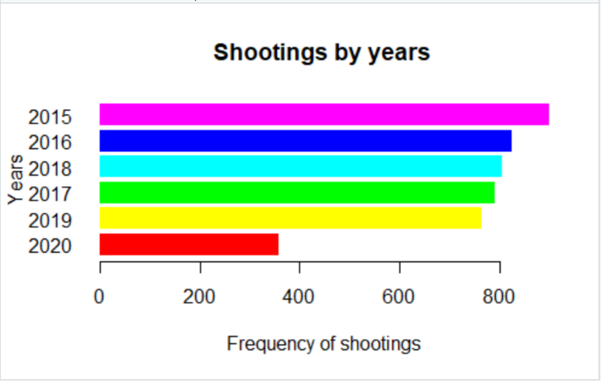

The above graph indicates the number of shootings over the years. As we can see over the time of 5 years, the number of shootings has been decreased. This indicates that there might be a relationship in the number of killings over the period. Hypothesis statement: The number of killings decrease over time, as people are cognizant over their biases. Hence, the decrease in the number of shootings. Please note: the number of shootings for the year 2020 dates to the month of August.

We have checked the relationship between people who was shot, and the officer was wearing body camera:

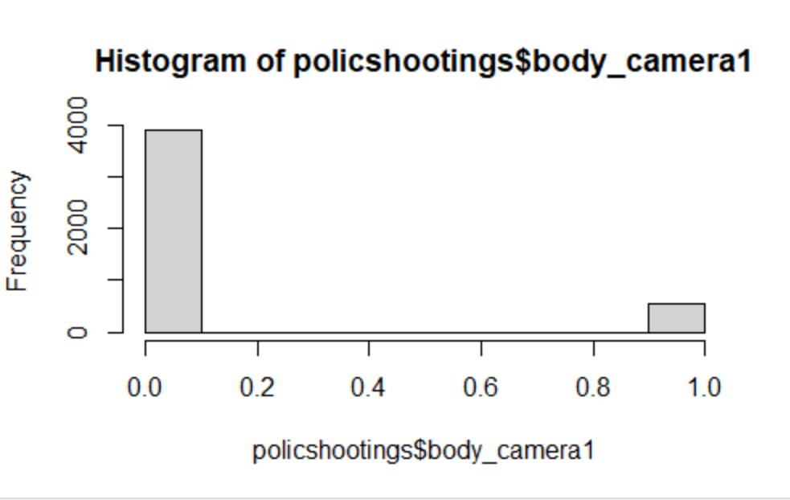

This graph indicates the number of times police wore a body camera while people were killed. This result indicates many people who were shot by the police had not been equipped with a body camera. This shows a lack of governance in the functioning of police system and need to have cameras to mitigate biases. Note: 0 indicates the number of times body camera was not worn. 1 indicates the number of times body camera was worn.

Age distribution of the number of people killed in different race:

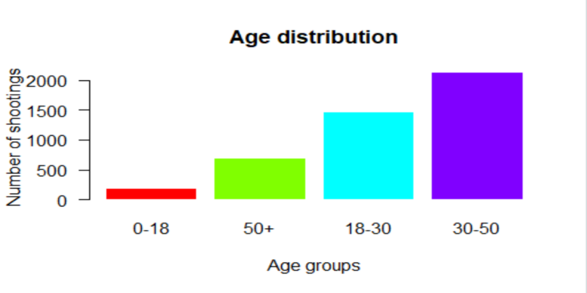

The age group where the greatest number of killings occurred is between age group 30-50.

However, no matter what their race is, there is lots of people who experiences police shooting. So, we decide to analyze why police shooting is happened and how we can reduce racism and prevent police power abuse.

We build several models to find why police shooting happened. A legitimate reason of police shooting would be self-defense. Assume, if victim was fleeing, it is hard to say a self-defense, most of cases. According to the model, if victim’s race is black than there is positive relationship with fleeing victim. Assume that base line is “unarmed, not black, no mental illness symptoms.”

If victim is armed, their possibility to flee is 38% smaller than base line. If victim show mental illness symptom, their possibility to flee is 68% smaller than base line. If victim is black, their possibility to flee is 22% larger than base line.

On the other hand, most of the victims who attacked the police appear to be armed, and although racial differences are not large, they seem to exist to some extent. Assume that base line is “unarmed, neither black nor white, no mental illness symptoms, and not fleeing.” If victim is armed, their possibility to attack is 202% larger than base line. If victim is white, their possibility to attack is 48% larger than base line. If victim is black, their possibility to attack is 75% larger than base line. If victim is fleeing, their possibility to attack is 17% smaller than base line. If victim has mental illness, their possibility to attack is 25% smaller than base line. Thus, fleeing people are less likely attack the police. Whether they are armed or not lead offensive behavior much more than racial difference.

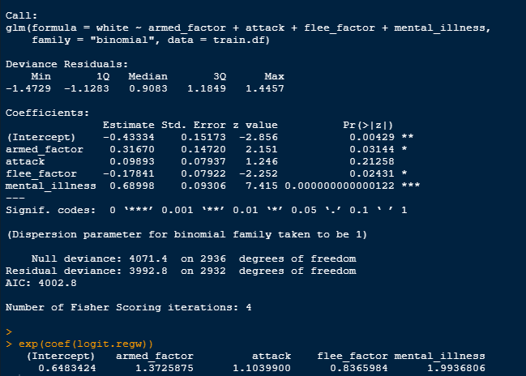

From both models, we can see each racial behavior. It shows how likely it is to be black or white based on the four behaviors that the victim has shown. If the victim is armed, victim is likely to be white. On the other hand, if the victim fled, victim's likely to be black.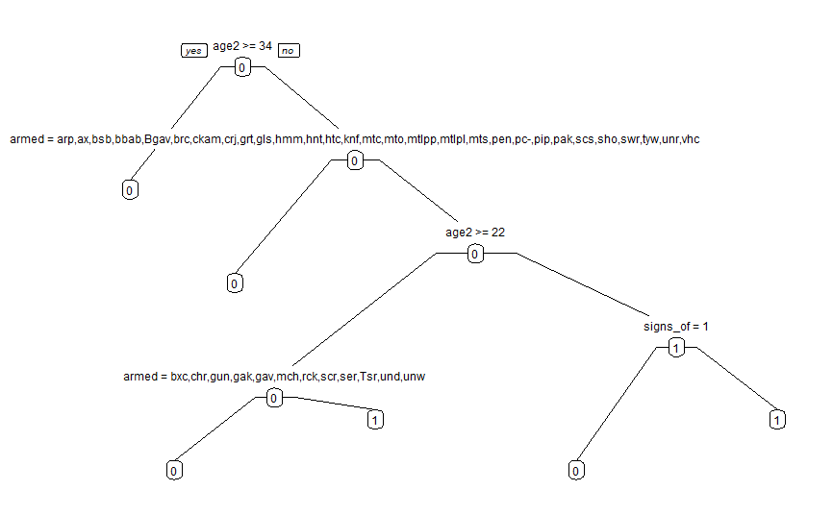

The decision tree model was run on Black victims who were unarmed and without mental illness symptoms are more likely black. Young black people are more likely to become a victim of police brutality. This can be regarded as an accident caused by hyperactivity against young blacks but instead of slowing them down or law enforcement are taking lethal action among people of color.

Conclusion:

The rate of fatal police shootings in the United States shows large differences based on ethnicity. Among Black Americans, the rate of fatal police shootings is higher than any other race. While the rate is relatively very low for White Americans. We recommend use of alternative weapons to catch the fleeing suspect, example: taser gun, rubber bullets, etc. Citizens cooperation is always required by law enforcement, officers should communicate with public to bring awareness at local level. Police should use body camera at all time. Instead of defunding the police, we should invest more in law enforcement in research, alternative weapons, and communication. Law enforcement officers should take classes in diversity and inclusion and the department should be well diversified by race, religion, and ethnicity.